**The Gun Debate: Are Gun Laws Effective at reducing Gun Violence?**



FIT5147 DATA EXPLORATION AND VISUALIZATION

Name: Lavi Samuel Rao

Student ID: 30703778

Tutor: Frank Wu

Lab Number: 20

Table of Contents

1. Introduction 1

**Message that I intend to convey:** 1

**Intended Audience:** 1

2. Design 2

**Summary of Five Design Sheet** 2

**Sheet 1(Idea Sheet)** 2

**Sheet 2** 2

**Sheet 3** 2

**Sheet 4** 2

**Sheet 5 (Realization Sheet)** 3

**Modifications in the final design:** 3

3. Implementation 4

**Libraries Used:** 4

**Datasets Used:** 4

**Datasets preparation:** 5

**User Interface Creation:** 5

**Server Side Creation:** 6

**Explaining individual elements of the shiny application:** 6

4. User guide 10

5. Conclusion 13

6. Bibliography 14

7. Appendix 15

# 

# 

# 1. Introduction

In recent years mass shootings in schools, universities and other public places have increased in the USA, which got me thinking why this isn’t the case in Australia. When I did my research, I found that Australia has gun laws that prevent the general public from owning firearms, which is not the case in the USA. So, to investigate whether gun laws in the USA are effective in controlling gun violence I started this project.

### **Message that I intend to convey:**

Initially I just had the gun violence incidents data set that I got from Kaggle, but this data was not enough for the findings I wanted to produce so I gathered some other data sets. After all the cleaning and wrangling processes were done, I started to create visualisations. I found that the best way to show the relation between the number of gun violence incidents in the USA and gun laws is to show it state wise since each state in the USA has different gun laws. So, it was best to show this data using a choropleth where the colour density shows the number of incidents and the tooltip will give information about the strictness of gun laws. I also wanted to show how factors like terrorism, gang activities and drug activities contribute to gun violence, for this I used bubble maps. Finally, I wanted the user to get an idea as to what categories of gun violence are present in the USA and which categories have how many incidents and the best way to represent this was using bar graphs.

### **Intended Audience:**

My main intended audience are citizens of the USA and people travelling to the USA. The citizens and anyone planning to visit the USA can use this application to get an idea as to which states would be safest and which states would be the most dangerous to live in or travel to. This application will also provide information on which gun laws are present or absent in which states and finally there is also the option to see how many accidents and self-harm cases are caused because of guns. All this information will help the user to decide whether the right to own a gun protects them or puts them in harm's way.

# 

# 

# 2. Design

Visualisation design process was started by creating the five design sheets. These sheets helped me in getting a clear picture of what my final application would look like.

## **Summary of Five Design Sheet**

### **Sheet 1(Idea Sheet)**

The first sheet was the idea sheet which gave me clarity on what type of visualisations and what information needs to be imparted. Once the visuals and the information that they would give to users were finalized I designed three alternative designs which are individually explained below.

### **Sheet 2**

The main information that I wanted to give out with this design sheet was how many Gun Violence incidents were there in different states of USA per 100000 inhabitants, this was shown by the choropleth map of USA where the colour density shows the number of incidents. The second thing that I wanted to show with this design was the different categories into which these gun violence incidents were categorised. To show this I used bar graphs which show the number of incidents in each category, also the categories are differentiated by the colour of the bar. In this design the user has the option to select the year for which he/she wants the information for. One drawback of this design was that the user did not get any information on the relation between gun violence and the gun laws in the respective states. To tackle this issue, I made the next design alternative.

### **Sheet 3**

This design sheet is an improvement from the previous design since the choropleth in this design shows a relation between gun violence incidents and the level of strictness in gun laws in those states. In this design if the user wants to see which laws are present in which states the used can even do this by selecting the specific laws for the drop down menu, and if they want to see the overall strictness of the gun laws they can click on the check box which will show them the strictness choropleth. One more improvement of this design was that since there were more than 130 categories of gun violence incidents a slide bar is provided with the bar graph so that the user has an option of selecting the top N categories to view. One drawback of this design was the user did not have the freedom of selecting the year for which they wanted the information for. The user is shown combined information from 2013 to 2018.

### **Sheet 4**

In design sheet drawbacks of the previous design was fixed by adding the year drop down menu and one more additional tab was added in the navigation bar which contains a bubble map which will show how big a factor is terrorism, drugs and gang activity when it comes to gun violence. The radius of the bubble represents the number of victims and the bubble itself is showing the location of the incident. The users can navigate between different bubble maps using the options in the drop-down menu provided with this visualisation.

### **Sheet 5 (Realization Sheet)**

This is my final design. This design contains three different windows which can be viewed by clicking on the options provided in the navigation bar on the top.

**Window 1:**

This window contains three choropleth one for incidents per 100000 inhabitants, one for strictness of gun laws in states and one for different types of gun laws in each state. Options that are provided to the user are selecting the year, type of gun law, radio button to view different choropleths.

**Window 2:**

This window contains a bar graph to show the different types of gun violence categories and number of incidents in each category. Users are provided with the option of selecting top N categories by moving the sliders bar and a checkbox to see non-violent categories.

**Window 3:**

This window contains the bubble map which shows the terrorism, drugs and gang activity factor. Users have the option to select which factor they want to view by selecting this from the drop-down menu. Also, there is an option to select the year.

All the above visualisations in this design are interactive, that is by hovering over each visualisation the user gets more information for example if the user hovers over the bar graph for categories they can see the exact number of incidents in that category along with the category name in the tool tip, if the user hovers over a particular state in the choropleth they can see the name of the state and if it's the incidents per 100000 inhabitants choropleth they can see the number of incidents in that state in the tool tip.

### **Modifications in the final design:**

* Once the final design sheet was ready, I noticed that window 1 contained too many choropleths which might confuse the user so to rectify this I placed the individual gun laws choropleths in a separate window.
* The other minor change that I made in the final design was the removal of the year option from window 2 and 3. This was done because the project was not to see how incidents have increased over time but to see an overall picture of what the gun violence scene looks like in the USA.
* Drop down menus were replaced by radio buttons because the options were less in number and radio buttons provided a clearer picture of the option available.

# 3. Implementation

To implement this project, I have used R Shiny. I had already done the cleaning and pre-processing of the data set during the last project. To create visualization in the Shiny application I used the already pre-processed dataset. The first step in creating the shiny application was to load the libraries.

### **Libraries Used:**

1. **dplyr** : This library was used to manipulate the data sets used in this project. Functions like filter(), select(), mutate() and many more were used to mutate data sets and get the desired output.
2. **ggplot2**: ggplot2 is included in the tidyverse package, ggplot2 is used to create beautiful visualization in R. I specifically used this to create interactive bar plots for different types of gun violence categories.
3. **leaflet**: This library is an open source JavaScript library. This is used to create interactive maps and visuals in R. I used this library to create interactive choropleths for strictness of laws, type of laws and incidents per 100000 inhabitants in the USA.
4. **shiny:** Helps in building shiny applications and contains functions like renderLeaflet() and renderPlotly().
5. **shinydashboard:** This library was used to create the shiny dashboard.
6. **rgdal:** This library was used to read the Geospatial dataset into R.
7. **Plotly:** This was used to convert visualisations generated by ggplot into interactive ones by adding a tooltip.

Once I installed the required libraries I loaded the data sets required to generate the visualization.

### **Datasets Used:**

1. **usa_vio (**236485 obs. of 35 variables**):** This is the main data set that contains all the gun violence incidents from 2013 to 2018. It has attributes like latitude, longitude, number of victims, state, city and others.
2. **incidentsByState(**51 obs. of 17 variables**):** This data set contains the incident numbers state wise also I have attached the strictness column in this dataset during pre-processing.
3. **inc_cat(**574356 obs. of 5 variables**) :** This dataset contains categories of gun violence and the number of incidents in each category.
4. **gun_law(**50 obs. of 8 variables**):**  This data set contains data regarding which law is present in which state of the USA.
5. **usa_pop(**51 obs. of 9 variables**): T**his is the population data set of USA segregated state wise.
6. **cb_2017_us_state_500k:** This is the spatial data set of the USA which is used to generate the choropleths.

### **Datasets preparation:**

To create choropleths spatial data is used but before I created these choropleths, I had to add the required attributes to the spatial dataset. These attributes were Per100k (contains incidents per100k state wise), Strictness (this is the score generated by adding the scores to different types of gun laws in different states of USA), Firearm.Registration.Required, Open.Carry.Legal, Permit.Required.to.Carry, Permit.Required.to.Purchase. Now that we have added all the required attributes to the spatial data set, we just need this data set to generate the choropleths. There was one final thing I did before creating the user interface which was creating a database which had entries from the **inc_cat** table but only categories which belonged to self-harm, self-defence and accidents were selected.

### **User Interface Creation:**

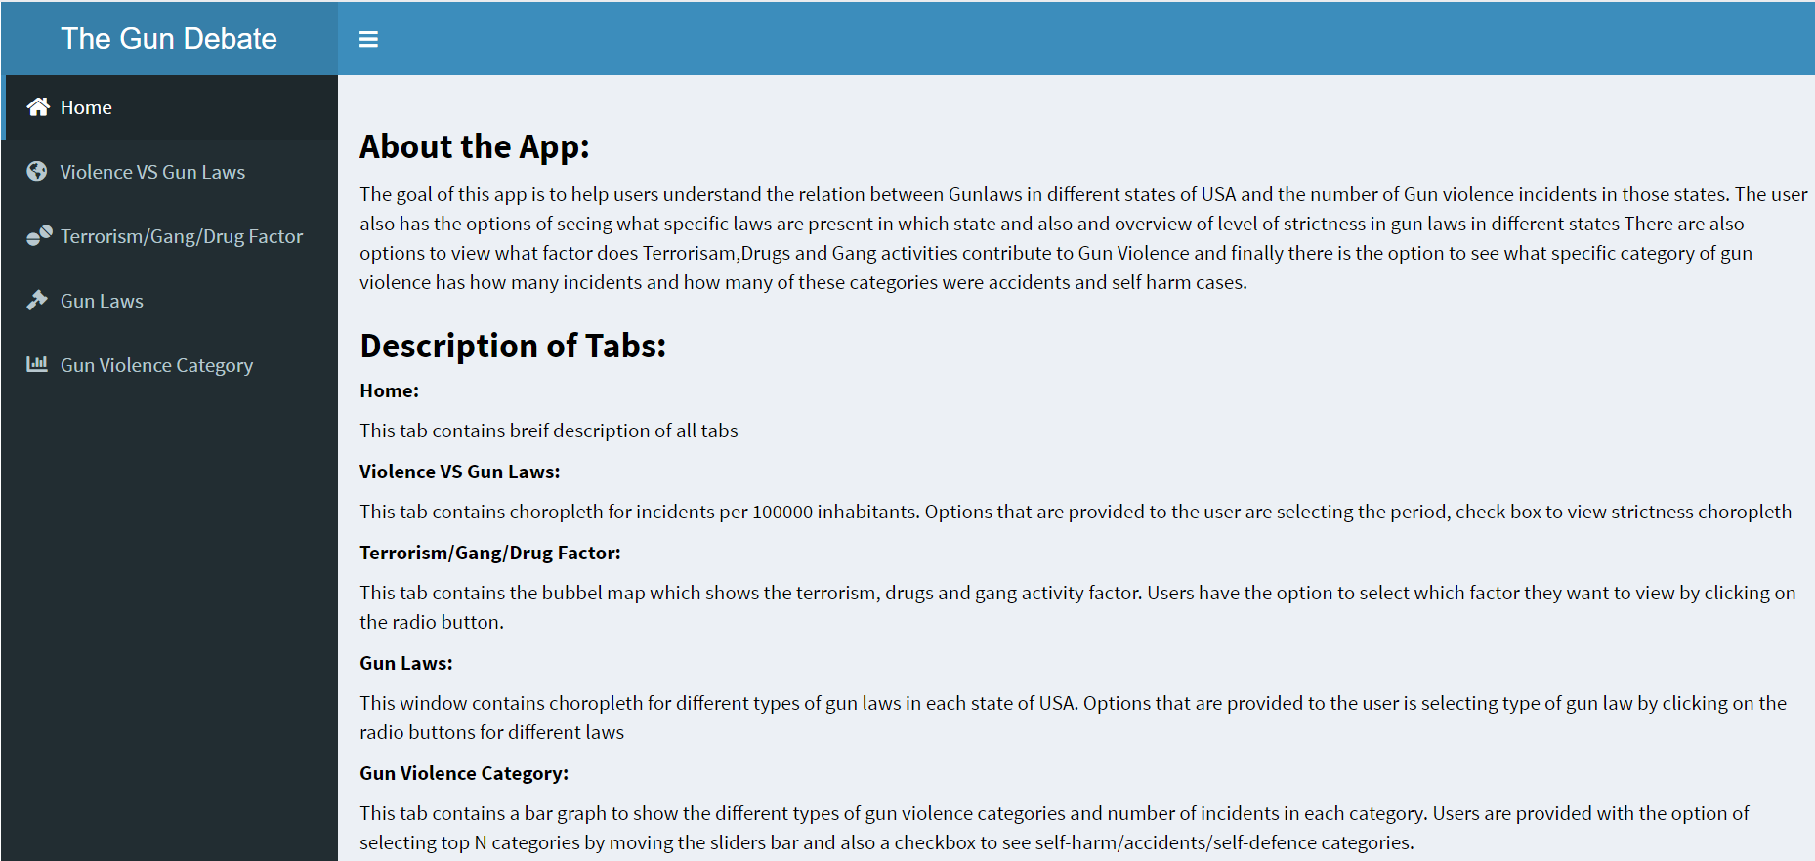

The final user interface looks like this. This is the first page of my application. To create this user interface I made use of a shiny dashboard. The dashboard has three main parts: the header, the sidebar and the body.

**Dashboard Header :**

The shiny header contains the heading that you want the application to have. In this project's case it is “The Gun Debate”. In the above screen shot the header can be viewed on the top left-hand side.

**Dashboard Sidebar :**

As the name suggests the dashboard sidebar is the bar present on the left side of the above screen shot. The sidebar is used to place any option that you want to be globally present in the application. In this project I have used the sidebar to place the various options like Home, Violence VS Gun laws, Terrorism/Gang/Drug Factor, Gun laws and Gun Violence Category. These options are basically used to navigate to different tabs present in the application. Each menu item is given a tab name, which is used to link this menu item to the page to which we redirect on clicking this menu item.

**Dashboard Body :**

In the dashboard body user interface code for individual web pages is written. tab name is used to link this UI code with the menu item created above. Code for the introduction page is also placed here. Code to create a slider bar, checkbox and date selection is also placed in the dashboard body. Input from here is sent to the server side, then the server side processes the input and sends back an output. Functions like leafletOutput() and plotlyOutput() are used to display the graphs generated in the server side on the user interface.

### **Server Side Creation:**

Server side contains the main processing code for the application. Code to generate all the visualisations is placed on the server side. Inputs sent from the UI are processed here and based on the input the data is manipulated and in turn the visualisations are manipulated. For example, input from the date range is sent to the server side, based on the date sent from the UI side the data set is filtered which is then used to generate the choropleth for the entered time period. Functions like renderLeaflet() and renderPlotly() are where the code to generate choropleths and bar graphs are placed which in turn sends these to the user interface to be displayed on the webpage.

### **Explaining individual elements of the shiny application:**

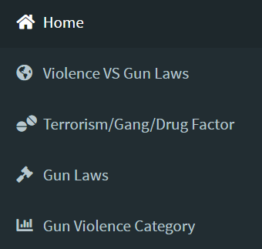

This menu is used to navigate through the shiny application by default the selected tab is home when the app opens.

**HOME Tab:**

This tab contains basic information about the app and brief information on different tabs.

**Violence VS Gun Laws Tab:**

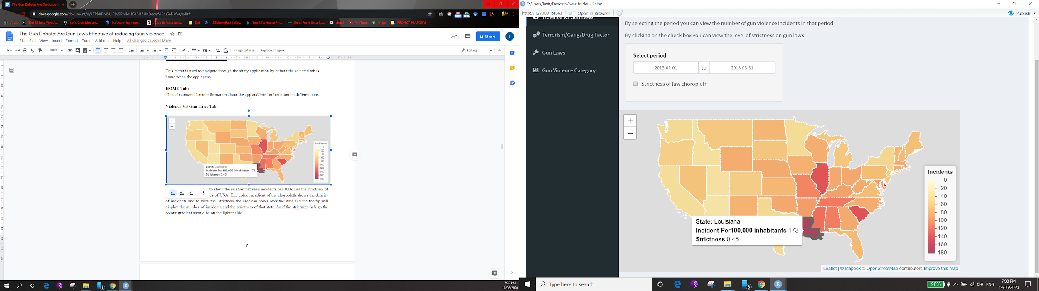

This choropleth is used to show the relation between incidents per 100k and the strictness of gun laws in different states of USA. The colour gradient of the choropleth shows the density of incidents and to view the strictness the user can hover over the state and the tooltip will display the number of incidents and the strictness of that state. So, if the strictness in high the colour gradient should be on the lighter side.

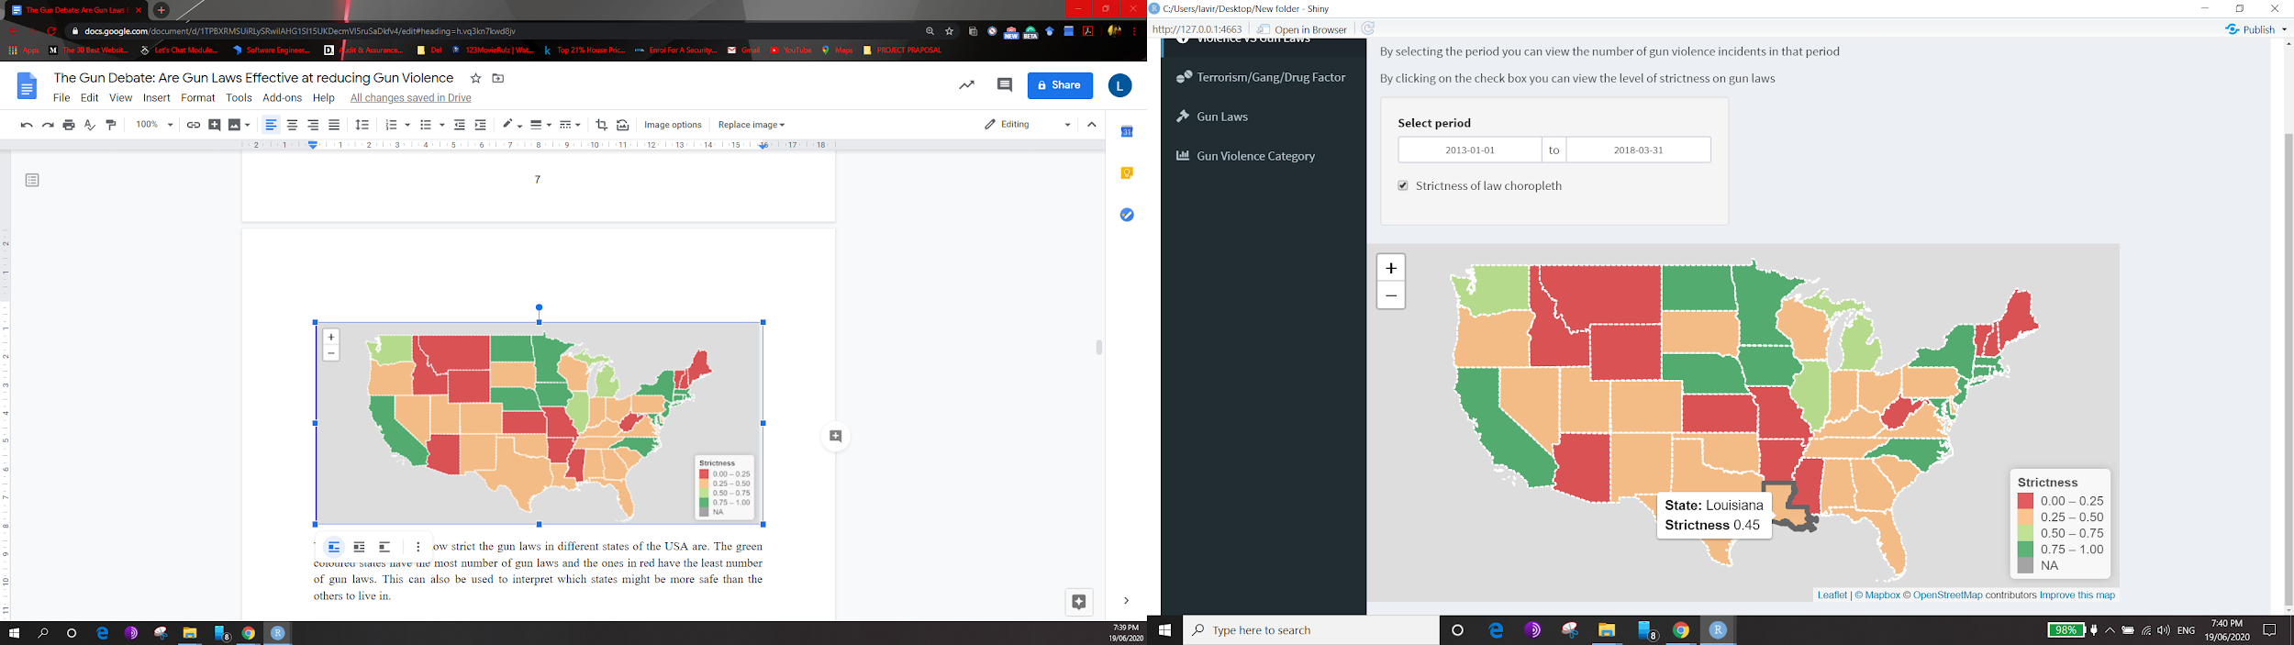

This choropleth shows how strict the gun laws in different states of the USA are. The green coloured states have the greatest number of gun laws and the ones in red have the least number of gun laws. This can also be used to interpret which states might be safer than the others to live in.

**Terrorism/Gang/Drug Factor Tab:**

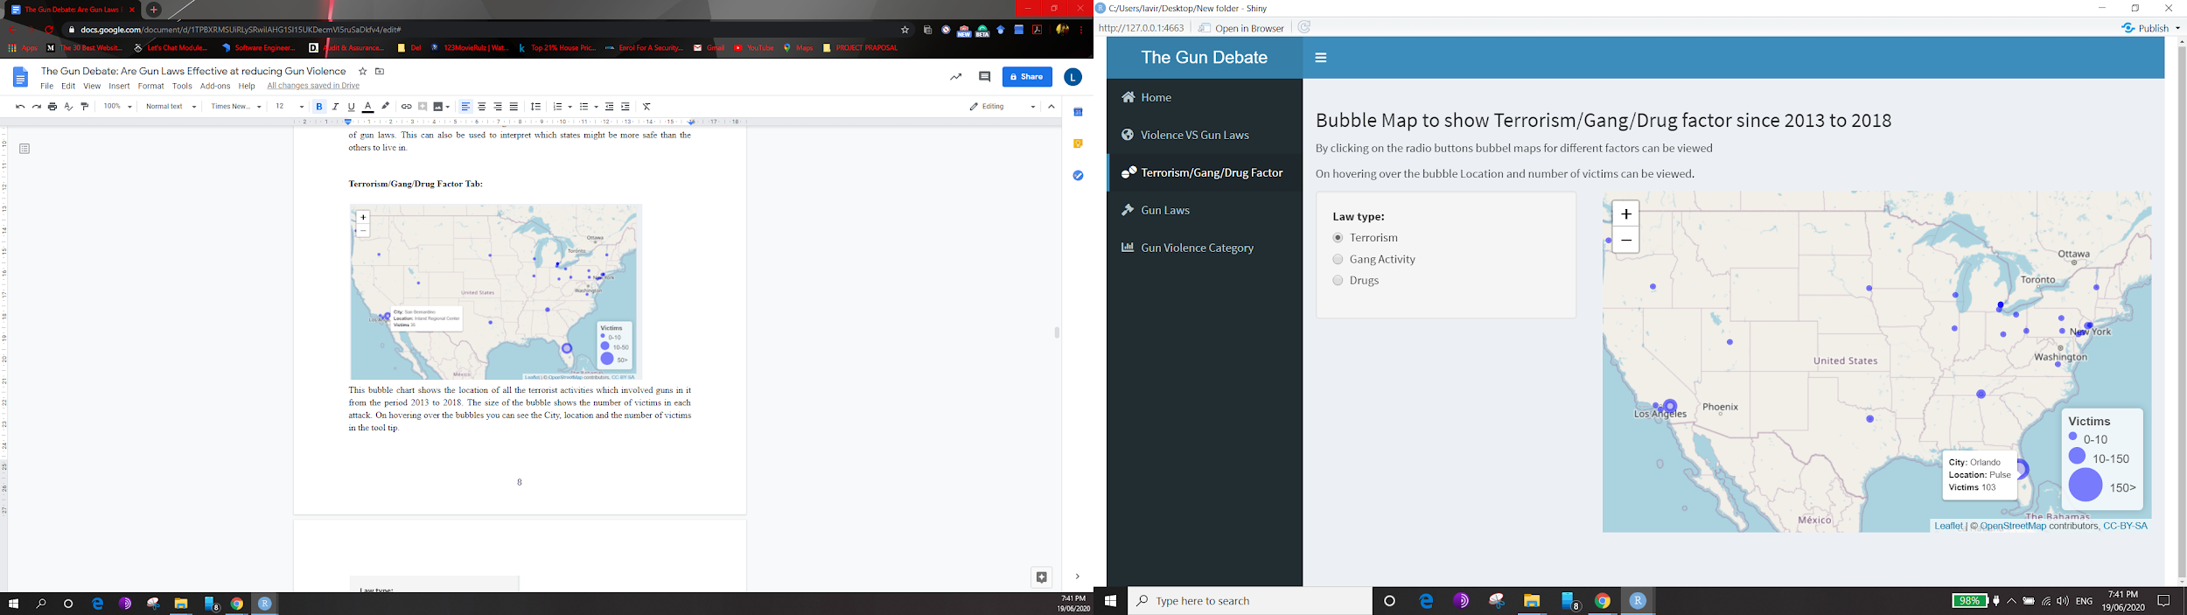

This bubble chart shows the location of all the terrorist activities which involved guns in it from the period 2013 to 2018. The size of the bubble shows the number of victims in each attack. On hovering over the bubbles, you can see the City, location and the number of victims in the tool tip.

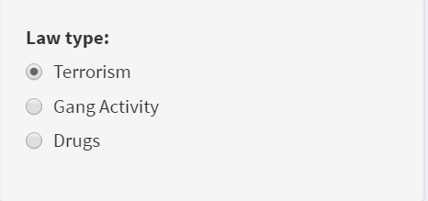

The user has the option to select from these three factors. Similar bubble maps are gendered for the other two factors also when the radio button is clicked.

**Gun Laws Tab:**

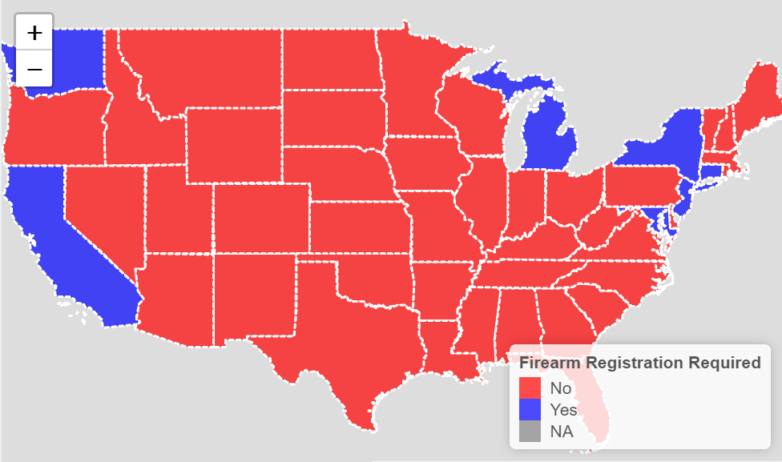

This choropleth shows which state the US has or doesn't have a particular gun law. I felt choropleth is a better way of displaying this since the user can also compare individual laws effect with the overall incidents per 100k in that state.

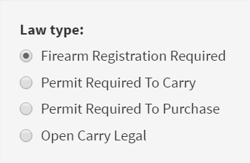

With the above Gun Laws choropleth these radio buttons are also provided so that the user can change the type of law for which they want to view the map.

**Gun Violence Category Tab:**

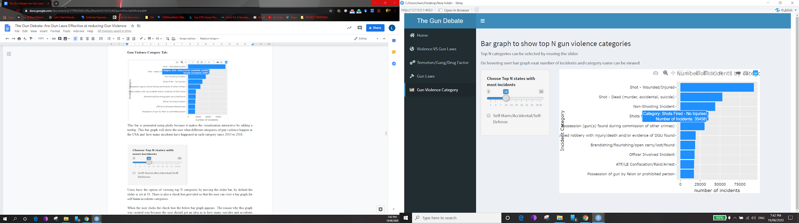

This bar is generated using plotly because it makes the visualization interactive by adding a tooltip. This bar graph will show the user what different categories of gun violence happen in the USA and how many incidents have happened in each category since 2013 to 2018.

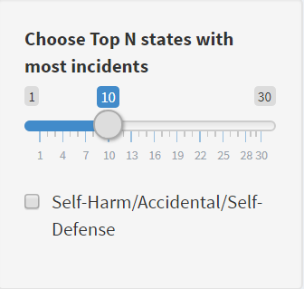

Users have the option of viewing top N categories by moving the slider bar, by default the slider is set at 10. There is also a check box provided so that the user can view a bar graph for self-harm/accidents categories.

When the user clicks the check box the below bar graph appears. The reason why this graph was created was because the user should get an idea as to how many suicides and accidents happen because people possess a gun.

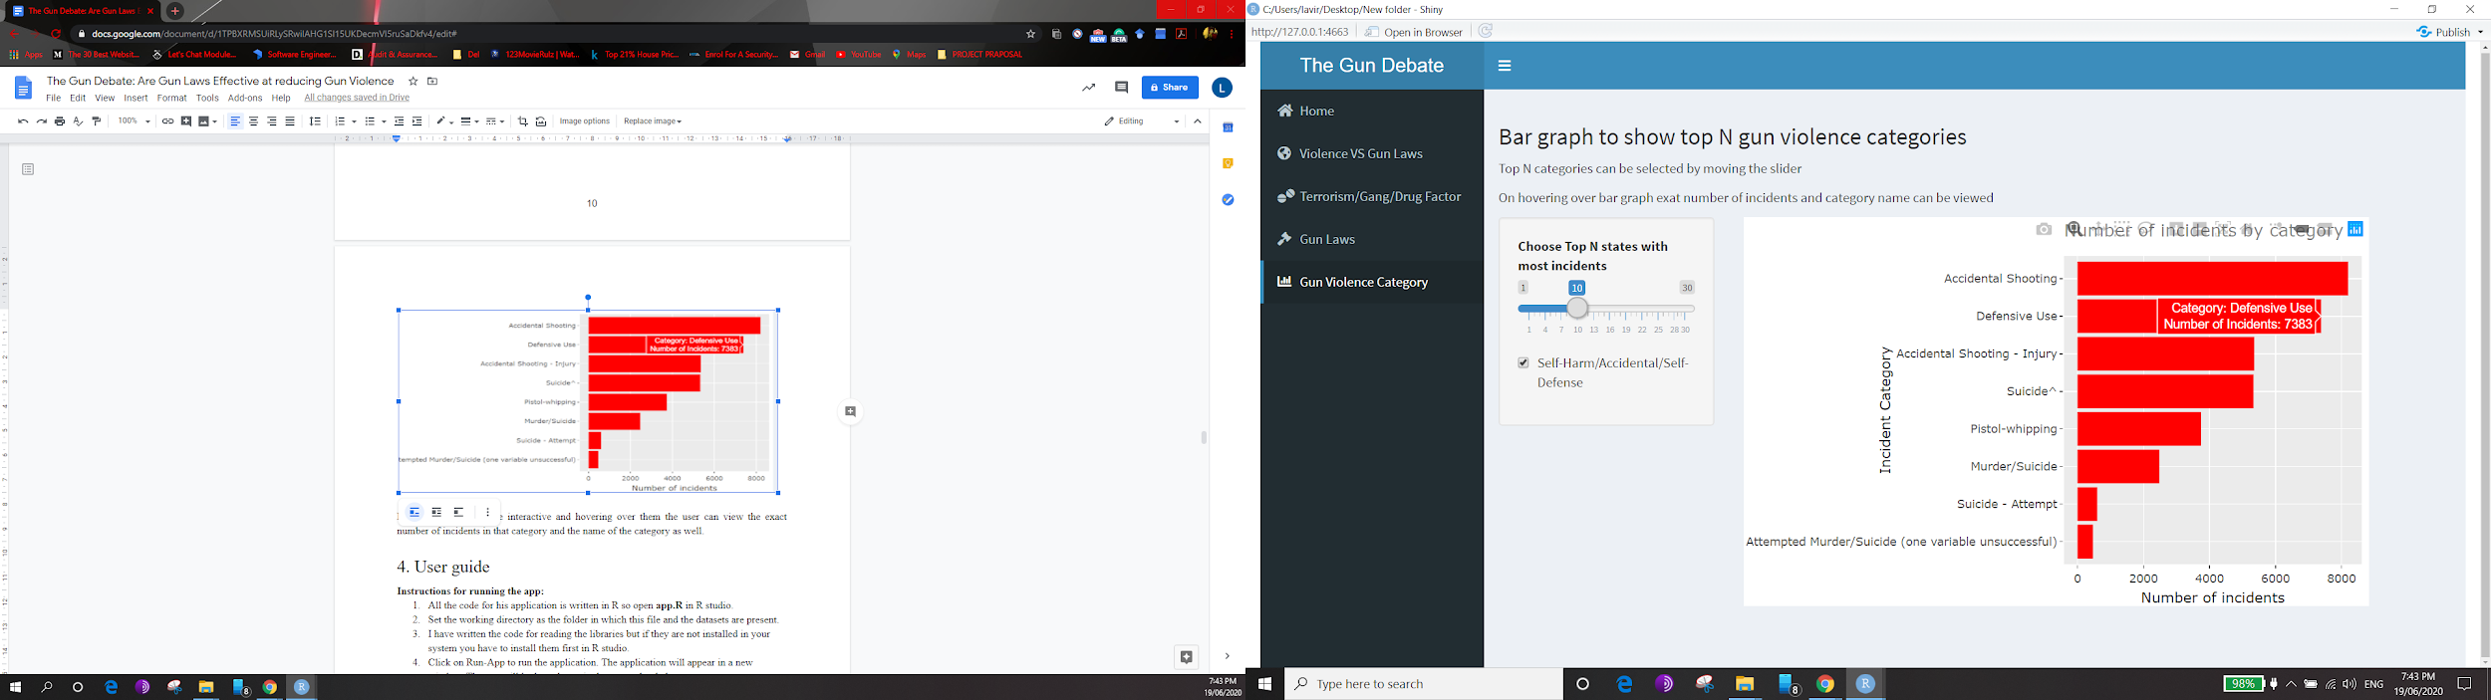

Both the bar graphs are interactive and hovering over them the user can view the exact number of incidents in that category and the name of the category as well.

# 4. User guide

**Instructions for running the app:**

1. All the code for his application is written in R so open **app.R** in R studio.
2. Set the working directory as the folder in which this file and the datasets are present.
3. I have written the code for reading the libraries but if they are not installed in your system you must install them first in R studio.
4. Click on Run-App to run the application. The application will appear in a new window. The app will look as shown in the screenshot below.
5. To understand how to use the menu bar and the individual functions provided in each tab respond refer to the screenshots provided below. They give a step by step walkthrough of the application.

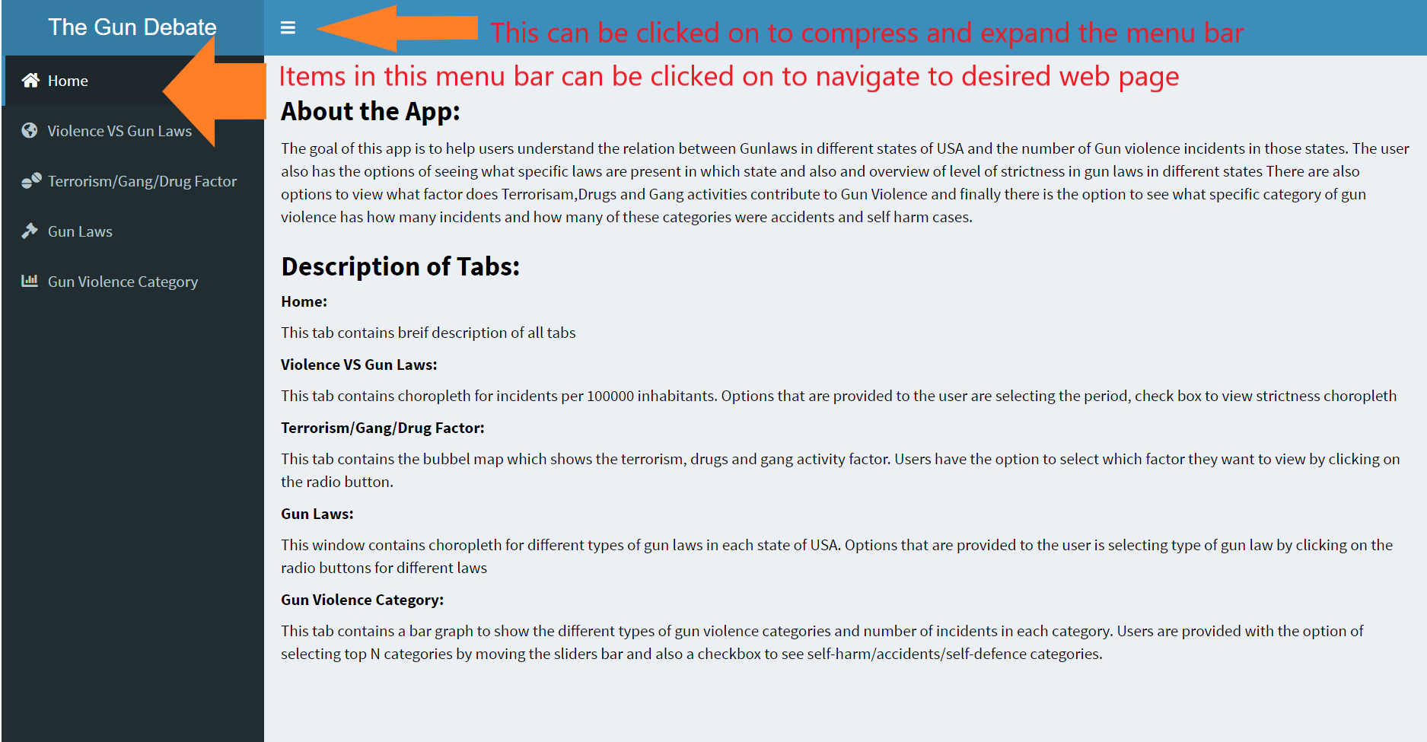

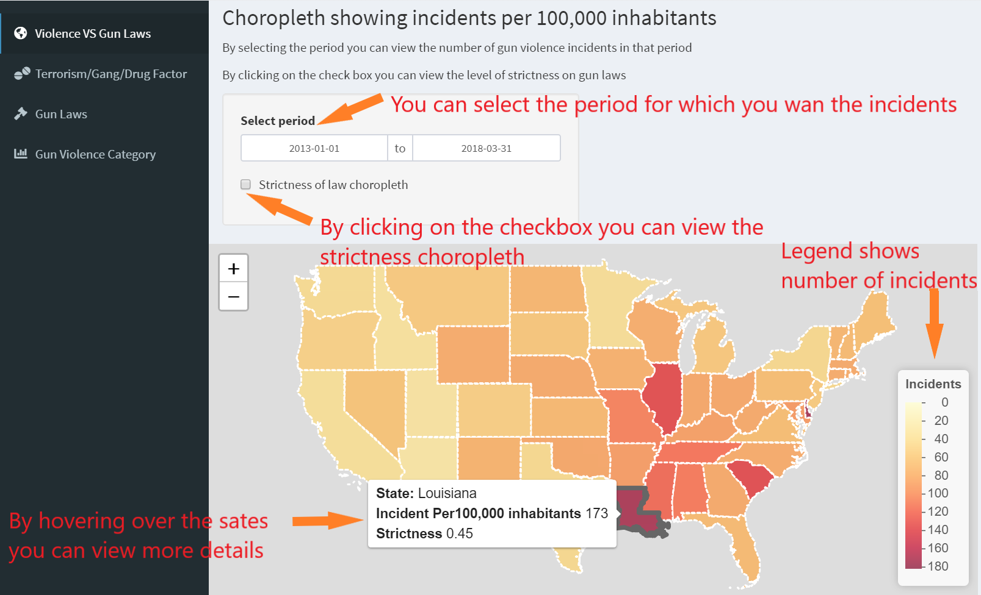

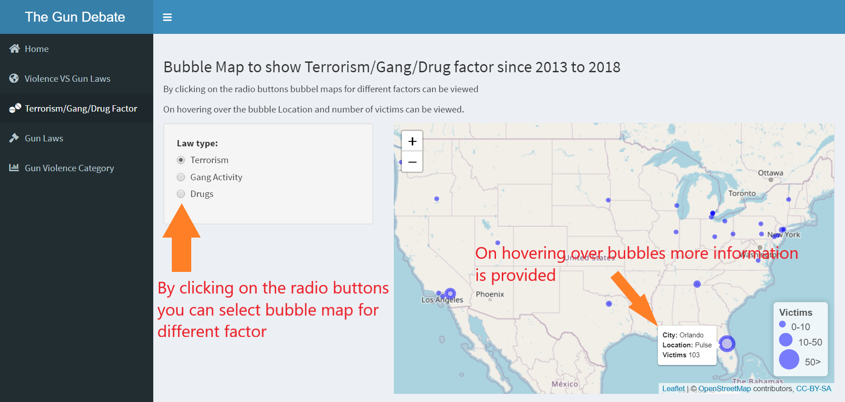

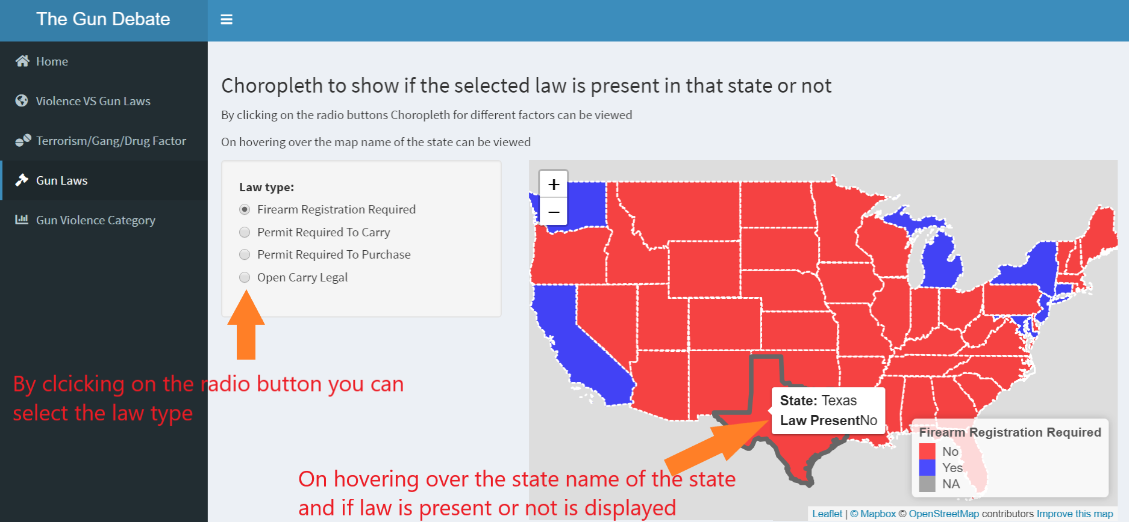

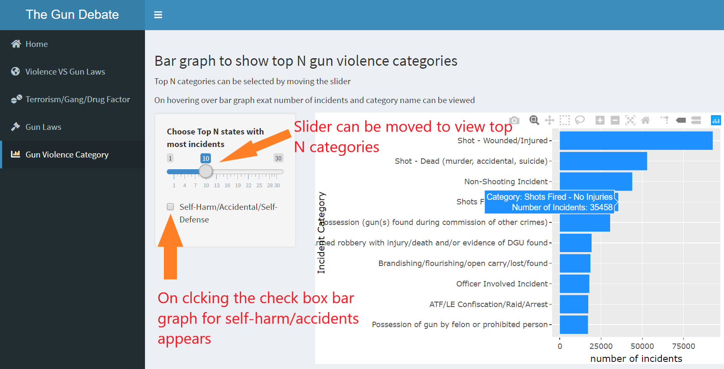

# 

# 5. Conclusion

The United States of America is currently going through a huge crisis of increasing numbers of gun violence incidents. The visualizations in this project will help the user to understand whether gun laws in the USA have resulted in curbing the number of gun violence incidents over the years. It is clear from the visualisation that states with more gun laws have less incidents per 100k inhabitants. In hindsight I would have worked on a few more dimensions of the topic like which gender is more affected? which age group is at the highest risk? Which age group is the most responsible for these incidents? And many such questions.

After doing all the research, exploratory data analysis and finally generating this narrative visualisation I concluded that if new laws and reforms are implemented gun violence can not only be reduced but can be totally eradicated in the USA.

# 6. Bibliography

Retrieved 19 June 2020, from https://worldpopulationreview.com/states/gun-laws-by-state/

CETINKAYA-RUNDEL, M. (2019). Shiny - Dashboards. Retrieved 19 June 2020, from https://shiny.rstudio.com/articles/dashboards.html

Fitton, D. (2020). Plotly in R: How to make ggplot2 charts interactive with ggplotly — Blog — Musgrave Analytics. Retrieved 19 June 2020, from https://www.musgraveanalytics.com/blog/2018/8/24/how-to-make-ggplot2-charts-interactive-with-plotly

Gun Violence Data. (2020). Retrieved 19 June 2020, from https://www.kaggle.com/jameslko/gun-violence-data

Index of /geo/tiger/GENZ2017/shp. (2020). Retrieved 19 June 2020, from https://www2.census.gov/geo/tiger/GENZ2017/shp/

Index of /programs-surveys/popest/datasets/2010-2016/state/asrh. (2020). Retrieved 19 June 2020, from https://www2.census.gov/programs-surveys/popest/datasets/2010-2016/state/asrh/

Leaflet for R - Introduction. (2020). Retrieved 19 June 2020, from https://rstudio.github.io/leaflet/

Swan, H. (2019). Custom legend with R leaflet- circles and squares in same plot legends. Retrieved 19 June 2020, from https://stackoverflow.com/questions/52812238/custom-legend-with-r-leaflet-circles-and-squares-in-same-plot-legends

# 

# 

# 7. Appendix

I am attaching my Five design Sheets here

